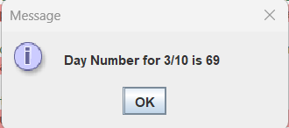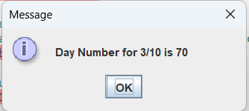

LeapDay:
package as05;

public class LeapDay extends Day
{
private int year;

public LeapDay(int d, int m, int y)
{
// Call parent constructor to initialize day and month
super(d, m);
// Initialize year yourself
year = y;
}

// over-ride the parent method
public int findDayNum()
{
// Call the parent findDayNum to determine dayNum
int dayNum = super.findDayNum();

// Handle if it is a leap year
if (((year % 400) == 0) || (((year % 4) == 0) && ((year % 100) != 0)))
{
// It is a leap year
// If month is greater than 2 add 1
if (month > 2)
{
dayNum = dayNum + 1;
}
}
return dayNum;
}

public int getYear()
{
return year;
}
}

TestLeapDay:
package as05;
import javax.swing.JOptionPane;

public class TestLeapDay
{
public static void main(String[] args)
{
int day, month, year, dayNum;
String input;

// Input day, month, year values
input = JOptionPane.showInputDialog("Enter day");
day = Integer.parseInt(input);

input = JOptionPane.showInputDialog("Enter month");
month = Integer.parseInt(input);

input = JOptionPane.showInputDialog("Enter year");
year = Integer.parseInt(input);

// Create an object of class LeapDay and pass its
// constructor day, month and year provided by the user
LeapDay leapDayObj = new LeapDay(day, month, year);

// Call findDayNum of LeapDay object & get day number
dayNum = leapDayObj.findDayNum();

// Display the original date and the day number
String output = "Day Number for " + month + "/" + day + " is " + dayNum;
JOptionPane.showMessageDialog(null, output);
}
}

